CTF WRITEUP TASK 1 OWASP & MULEARN KERALA
CTF Name: Hack The Box
Challenge Name: Meow
Category: Privilege Escalation, Nmap
Date Solved:12-07-2025
Author: Sunny Abraham Mathew
- Enumeration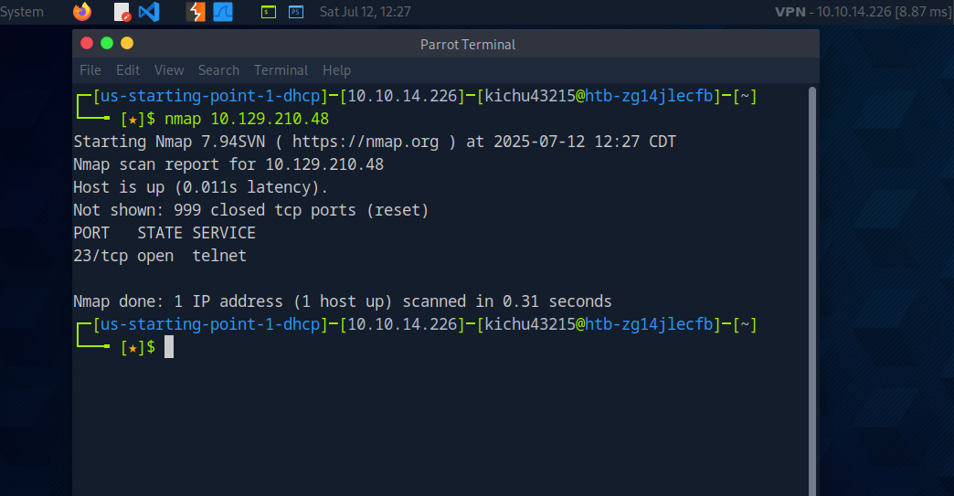
Started a Nmap scanned in the target ip and found out that port 23 was open. Which made me explore more about it.

2.Port Probing
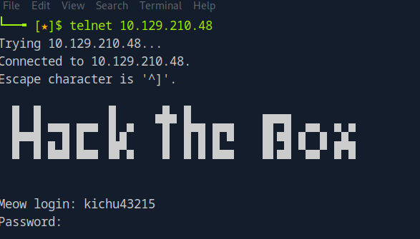
Scanned the particular port which led to a login page.
3.Credential Based Access
Tried to login using given Credential which didn’t work out.
4.Root Login Exploitation
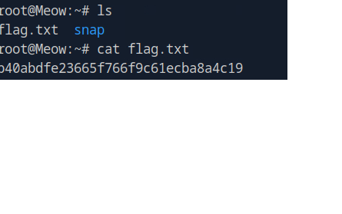
Got the root access and which indeed led me to the flag.

